Fire Pump Operation
These are the basics for setting up, starting and running the fire pump
SETUP
- Place the pump on a solid surface, close enough for the SUCTION HOSE to reach the water.
- Check there is gas in the tank.
- Prime pump - add water into prime port until it exits inlet port (use jug or boat bailer)
- Attach the SUCTION HOSE to the pump INLET and lock in place.
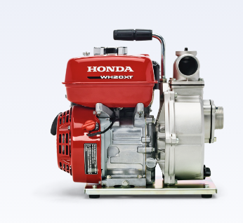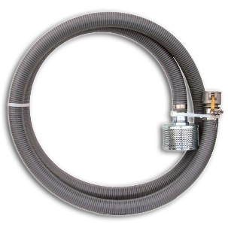
SUCTION HOSE w STRAINER
+
INLET

- Completely submerge the STRAINER in the water – may need weighing down.
- Unroll the DISCHARGE HOSES, make sure there are no twists or kinks.
- Attach the female hose end to the pump OUTLET, lock in place.
  - Multiple discharge hoses can be coupled together.
- Attach the NOZZLE to the end of the discharge hose(s) and lock in place.
- Prime pump via prime port – use lake water/boat bailer/cup etc – replace prime cap
PRIME PORT
NOZZLE
Discharge Hoses,
(Blue or White)
+
+
OUTLET
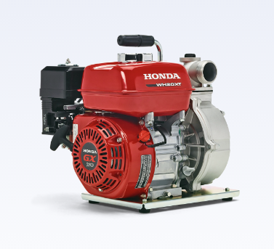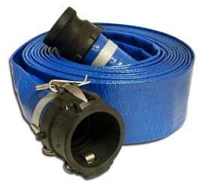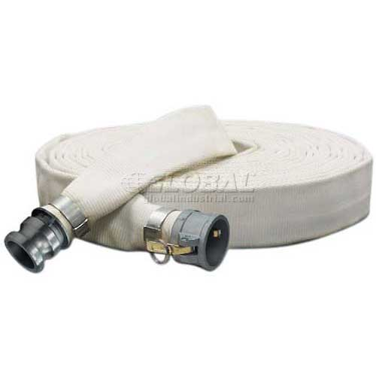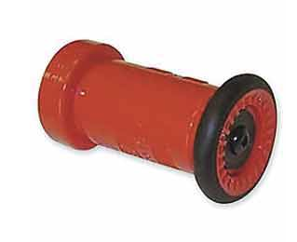
OR

You are ready to start the engine! Have someone holding the nozzle!
STARTING THE PUMP (TGIC)
Note: pumps in tubular metal cages do NOT have a gas on/off or an ignition switch
Throttle / Gas / Ignition / Choke
Throttle to the left
Gas to the right
Ignition to the “ON” position
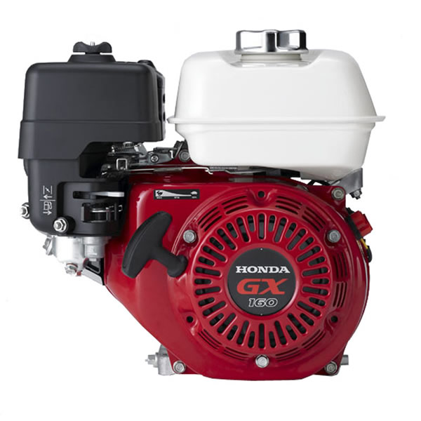
Choke to the left
THROTTLE
CHOKE
IGNITION
GAS

- Pull the starter cord until pump starts.
- Move the choke to the right.
- The pump will self-prime up the suction hose if you added water to the pump via priming port, it takes a minute!
- Have someone hold the nozzle, it’s powerful once the water flows!
- Aim water at the base of the fire, adjust nozzle spray pattern as needed

